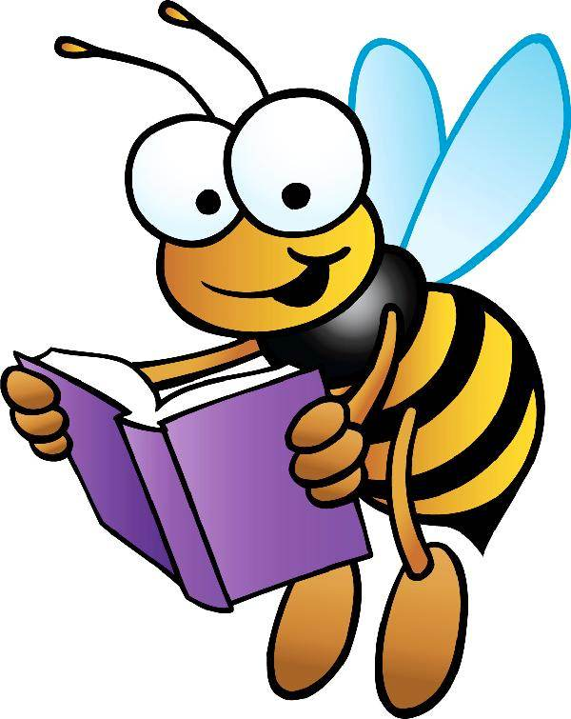
Literacy Resources for
Parents of Intermediate Level Children
(Grades 3-5)

Places to Visit:
Broward County Library: See website for free weekly events at your branch of the library.
http://www.broward.org/library
Barnes & Noble: See website for free events at a store near you. http://stores.barnesandnoble.com/stores?searchText=33301&view=list&storeFilter=all
Broward County Parks and Nature Centers: See websites for a variety of educational opportunities. http://www.broward.org/parks/Pages/Default.aspx
www.broward.org/Parks/FindNature/Pages/NatureCenters.aspx

Websites to Visit:
Florida Standards Assessments: Find specific information for students and families that include testing dates, understanding reports, and Frequently Asked Questions.
www.Fsassessments.org
Just Take 20: The Florida Department of Education campaign to provide K-12 Florida families with practical, easy-to-implement reading activities that establish literacy as a lifelong value.
www.justtake20.org
Florida Standards: Student & Parent Resources provided by the Florida Department of Education.
http://www.fldoe.org/academics/standards/florida-standards/student-family-resources.stml
The National Archives Museum: See website to explore our nation’s history through documents, photos, and records.
www.archives.gov
NEWSELA: Read articles and take quizzes on the go.
https://newsela.com
Readworks: Find free reading passages, skill and strategy units, and comprehension and novel study units.
www.readworks.org
Broward County Public Schools Parent Portal: Find access to information on student safety, monitoring your student’s school grades, curriculum resources, and much more.
http://browardschools.com/Parents-Students/Parents
Britannica School Online Encyclopedia: This online encyclopedia provides online resources for students at the elementary, middle, and high school levels. Username and password are required for home access through Beep, under the student login.
http://beep.browardschools.com/ssoPortal/index.html
Broward County Public Schools Library: Find your school and log in for access to multiple resources. http://destiny.browardschools.com/common/welcome.jsp
Broward County Library “WOW!” Without Walls: Download eBooks, audiobooks, and stream video to your device at no charge. You will need a library account, which is free for all Broward residents. http://broward.lib.overdrive.com/ECDFAFB0-6310-4EA4-924D-55592BB74E05/10/50/en/Default.htm
South Florida Parenting: Tips for parenting and information on different local events for kids.
http://www.sun-sentinel.com/features/south-florida-parenting/
Reading Rockets: Lots of reading related videos.
http://www.readingrockets.org/
http://www.readingrockets.org/reading-topics/reading-aloud
Spelling City: Use an existing list or practice your own words on this online platform. http://www.spellingcity.com/
ThinkReadWrite: A collaboration of the International Literacy Association and the National Council of Teachers of English. Check out their dedicated “parent” page.
http://www.readwritethink.org/parent-afterschool-resources/
Wonderopolis: An interactive site for all of those who ‘wonder’. Opportunities to get the whole family involved. http://wonderopolis.org/

