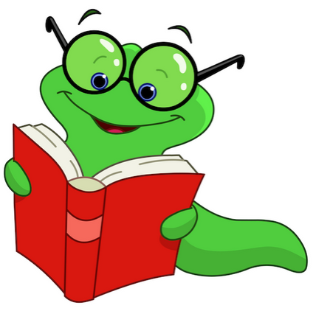
Literacy Resources for
Parents of Primary Level Children
(Grades K-2)
Places to Visit:
Broward County Library: See website for free weekly events at your branch of the library.
http://www.broward.org/library
Barnes & Noble: See website for free events at a store near you. http://stores.barnesandnoble.com/stores?searchText=33301&view=list&storeFilter=all
Broward County Parks and Nature Centers: See websites for a variety of educational opportunities. http://www.broward.org/parks/Pages/Default.aspx
www.broward.org/Parks/FindNature/Pages/NatureCenters.aspx
The Grocery Store: Have your child help create and monitor your shopping list or match coupons to the products in each aisle.

Websites to Visit:
Just Take 20: The Florida Department of Education campaign to provide K-12 Florida families with practical, easy-to-implement reading activities that establish literacy as a lifelong value.
www.justtake20.org
Florida Standards: Student and Parent Resources provided by the Florida Department of Education.
http://www.fldoe.org/academics/standards/florida-standards/student-family-resources.stml
Starfall: Free site to teach the basics of reading. Features interactive books and phonics games.
www.starfall.com
Tumble Books: Get the Broward password from your school’s Media Specialist.
www.tumblebooklibrary.com
Broward County Public Schools Library: Find your school and log in for access to multiple resources. http://destiny.browardschools.com/common/welcome.jsp
Broward County Library “WOW!” Without Walls: Download eBooks, audiobooks, and stream video to your device at no charge. You will need a library account, which is free for all Broward residents. http://broward.lib.overdrive.com/ECDFAFB0-6310-4EA4-924D-55592BB74E05/10/50/en/Default.htm
South Florida Parenting: Tips for parenting and information on different local events for children.
http://www.sun-sentinel.com/features/south-florida-parenting/
Reading Rockets: Lots of reading related videos.
http://www.readingrockets.org/
http://www.readingrockets.org/reading-topics/reading-aloud
Spelling City: Use an existing list or practice your own words on this online platform. http://www.spellingcity.com/
ABCya: Practice keyboarding and other skills in a game-based environment.
http://www.abcya.com/
ThinkReadWrite: A collaboration of the International Literacy Association and the National Council of Teachers of English. Check out their dedicated “parent” page.
http://www.readwritethink.org/parent-afterschool-resources/
Wonderopolis: An interactive site for all of those who ‘wonder’. Opportunities to get the whole family involved.
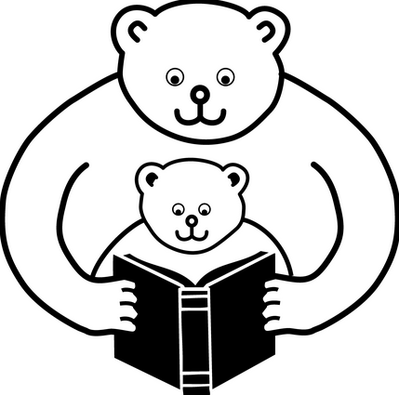
http://wonderopolis.org/
PBS Kids: Play reading games with your favorite characters.
http://pbskids.org/games/reading/
Reading is Fundamental: Activities to learn and play.
http://www.rif.org/books-activities/activities/by-topic/age-1/
Poetry sites: Find your inner poet.
http://www.poetryfoundation.org/
Play along with children’s poet Ken Nesbitt.
http://www.poetry4kids.com/
Storytelling: Build a foundation for your child’s future with stories of your past. http://www.scholastic.com/parents/blogs/scholastic-parents-learning-toolkit/storytelling-children

